LAB DOCUMENTATION
MINIMAX ALGORITHM AND ALPHA-BETA PRUNING

Lab Title
Implementation and comparison of Minimax and Alpha-Beta Pruning on a binary game tree.

1. Problem Statement
The task is to evaluate a game tree using Minimax, where MAX selects the highest value and MIN selects the lowest value. Alpha-Beta Pruning should return the same decision while reducing unnecessary leaf evaluations.

2. Minimax Algorithm
Minimax explores the tree from the leaves toward the root. Each MAX node keeps the larger child value, and each MIN node keeps the smaller child value.

2.1 Hand-Traced Minimax Tree
The notebook image below contains the hand-traced Minimax tree and the value calculations. The enhanced image is included for easier reading.
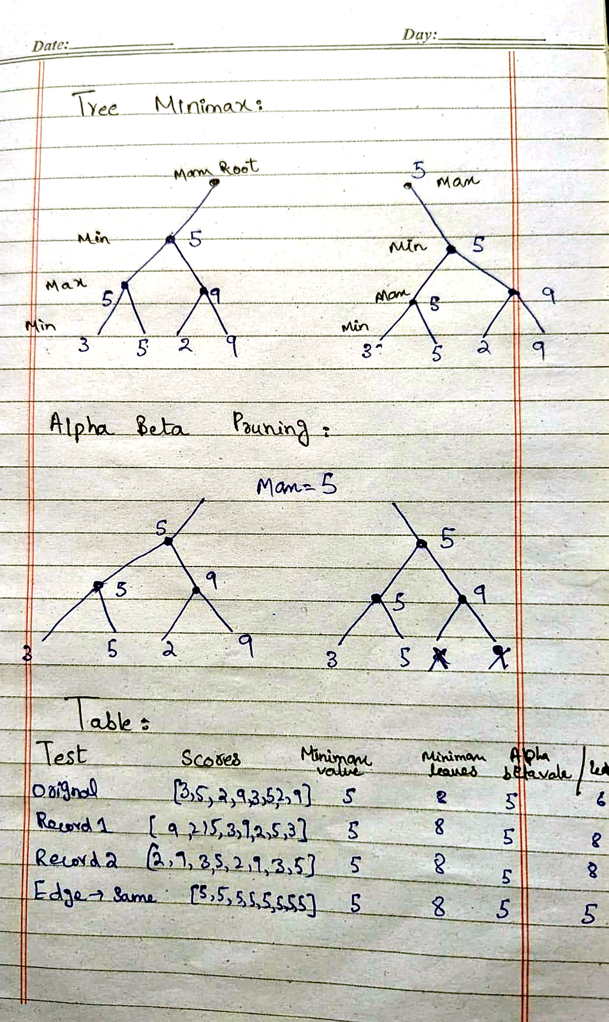
Figure 1. Hand-traced Minimax and Alpha-Beta trees, with the original comparison table.

2.2 Minimax Code Screenshot
The screenshot shows the recursive Minimax function and the test cases used in the program. A leaf counter records how many leaf nodes are evaluated.
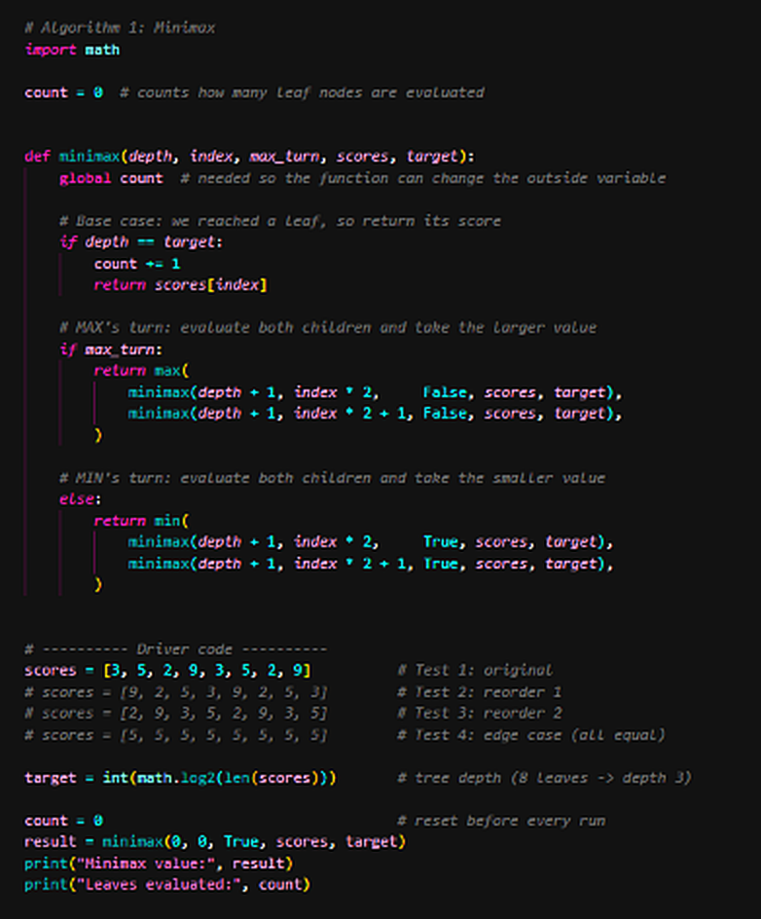
Figure 2. Minimax implementation and test-case list.

2.3 Minimax Output
The program returns a Minimax value of 5 and evaluates 8 leaves for the original ordering. This output is shown in the console screenshot.
Figure 3. Minimax console output.

3. Alpha-Beta Pruning
Alpha-Beta Pruning improves Minimax by skipping branches that cannot change the final result. Alpha is MAX’s current lower bound, while beta is MIN’s current upper bound.

3.1 Hand-Traced Alpha-Beta Tree
The notebook image marks pruned leaves with crosses. These branches are skipped because the current alpha and beta bounds show that they cannot improve the decision.
Refer to Figure 1, lower tree diagrams, for the hand-traced Alpha-Beta example and the crossed-out branches.

3.2 Alpha-Beta Code Screenshot
The code updates alpha at MAX nodes and beta at MIN nodes. When alpha is greater than or equal to beta, the loop stops exploring that branch.
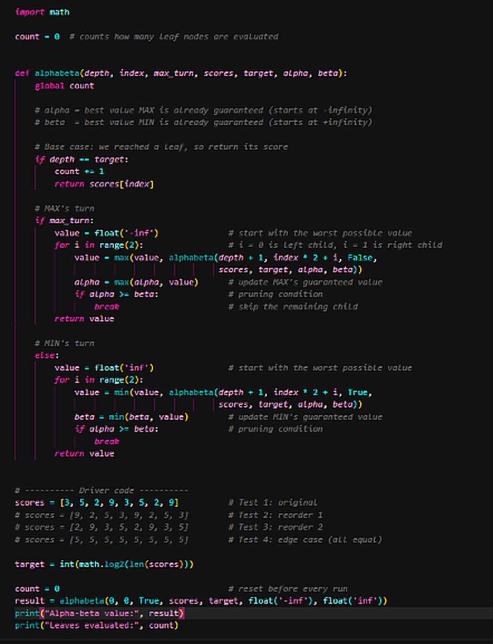
Figure 4. Alpha-Beta implementation and test-case list.

3.3 Alpha-Beta Output
For the original ordering, Alpha-Beta returns the same value as Minimax while evaluating fewer leaves. The provided output reports a value of 5 and 6 leaves evaluated.
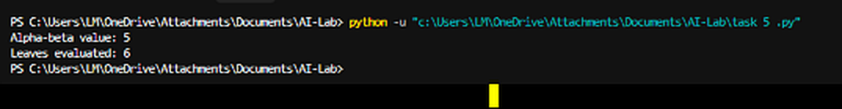
Figure 5. Alpha-Beta console output.

4. Comparison Table
The table compares the same tree values under three leaf orderings. The minimax value stays 5; the number of leaves evaluated by Alpha-Beta changes with ordering.
Test | Leaf Values | Minimax Value | Minimax Leaves | Alpha-Beta Leaves
Original | [3, 5, 2, 9, 3, 5, 2, 9] | 5 | 8 | 6
Reorder 1 | [9, 2, 5, 3, 3, 5, 3, 3] | 5 | 8 | 8
Reorder 2 | [2, 9, 3, 5, 2, 9, 3, 5] | 5 | 8 | 8

5. Edge Case Test
The edge case uses equal leaf values: [5, 5, 5, 5, 5, 5, 5, 5]. Both algorithms should return 5 because every possible leaf has the same score.
Test Case | Expected Value | Observed Alpha-Beta Output
All leaf values equal | 5 | 5 (5 leaves evaluated, as recorded)

6. Interpretation
Minimax and Alpha-Beta Pruning return the same optimal value of 5 for the tested tree. Minimax evaluates all 8 leaves, while Alpha-Beta can skip leaves when the bounds prove they are unnecessary. The original order evaluates 6 leaves, whereas the reordered cases shown in the code evaluate 8. Therefore, branch ordering affects pruning efficiency but not the final Minimax value.

